BÁO CÁO THỰC HÀNH LAB 3  
LẬP TRÌNH HƯỚNG ĐỐI TƯỢNG

# Basic Object-Oriented Techniques

## *3. Passing parameter:*

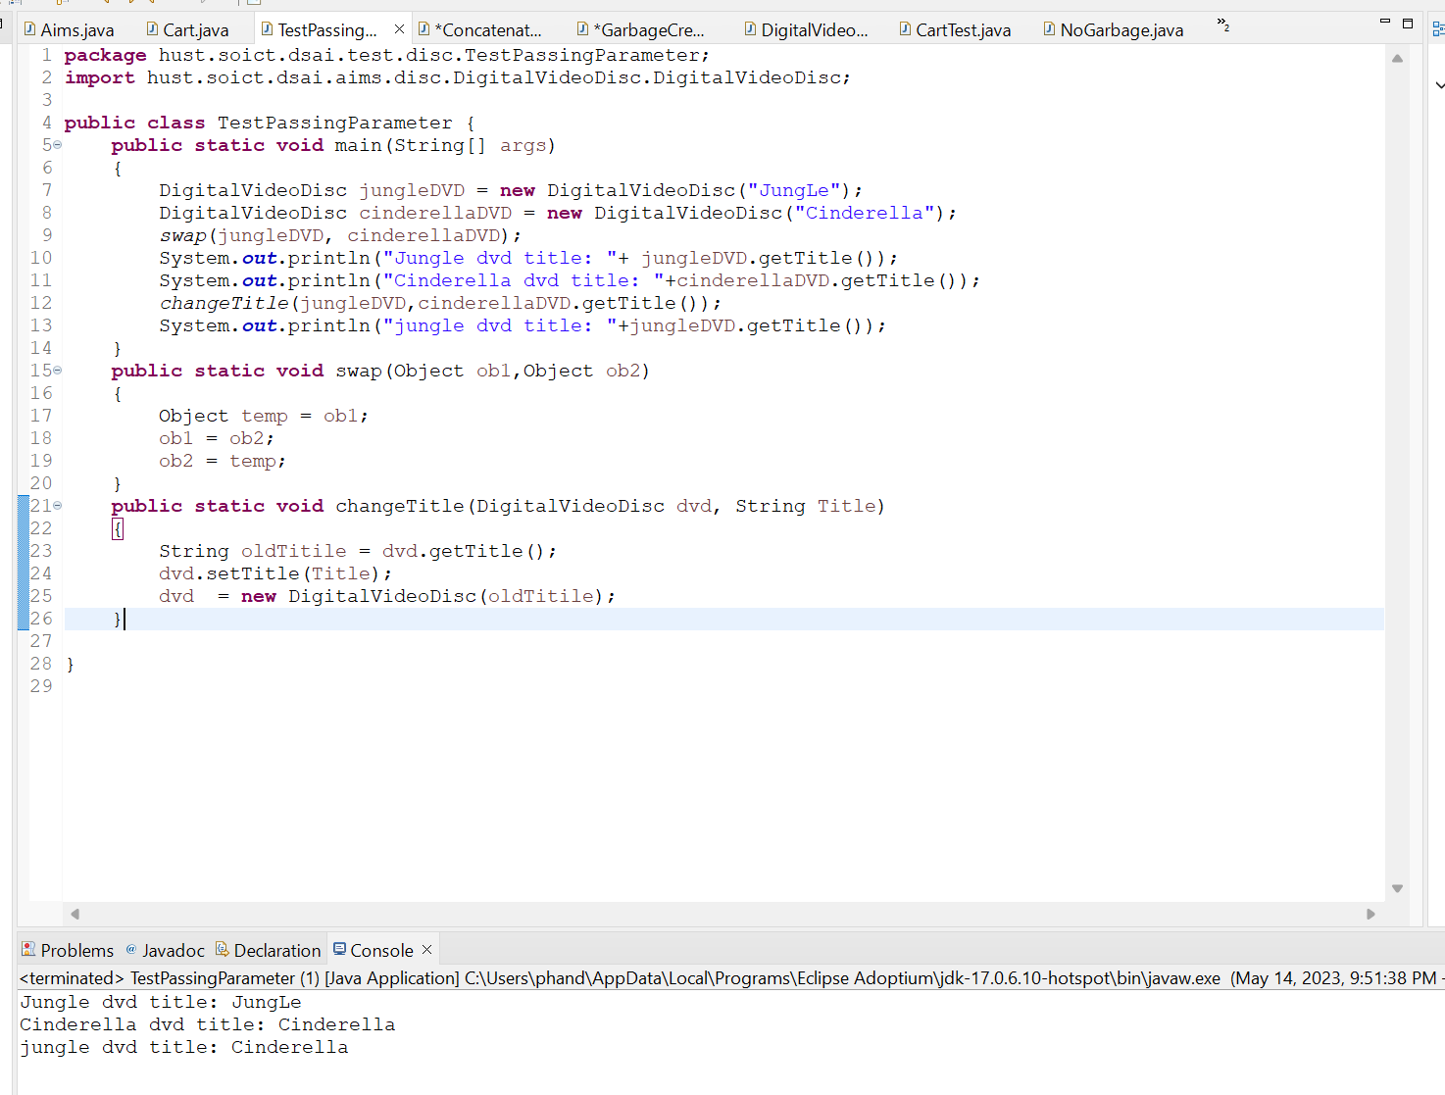

## 4. Use debug run:

4.2.1. Setting, deleting & deactivate breakpoints:

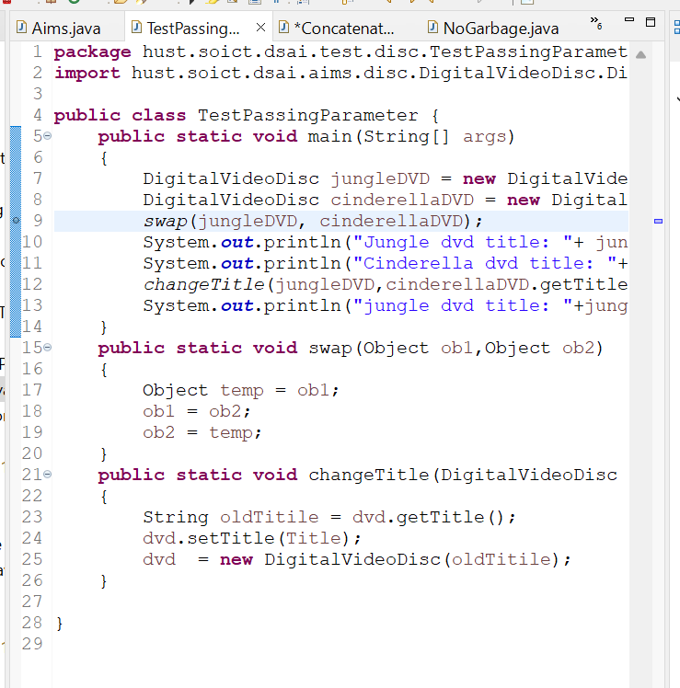

4.2.2. Run in Debug mode:

## 5. Classifier Member and Instance Member

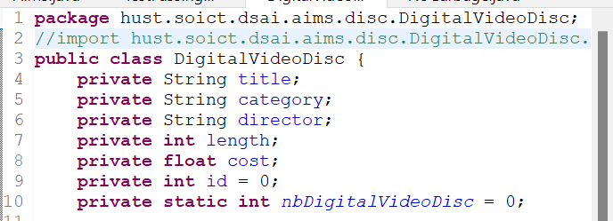

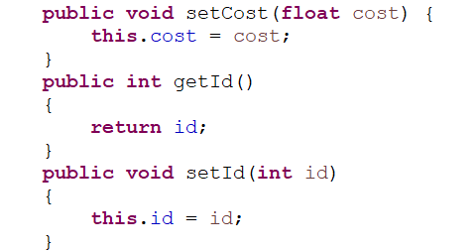

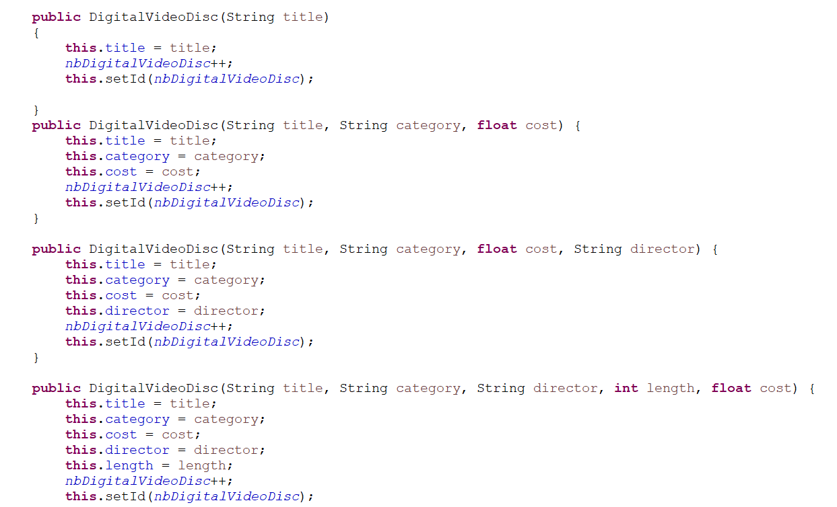

## 6. Open the Cart class

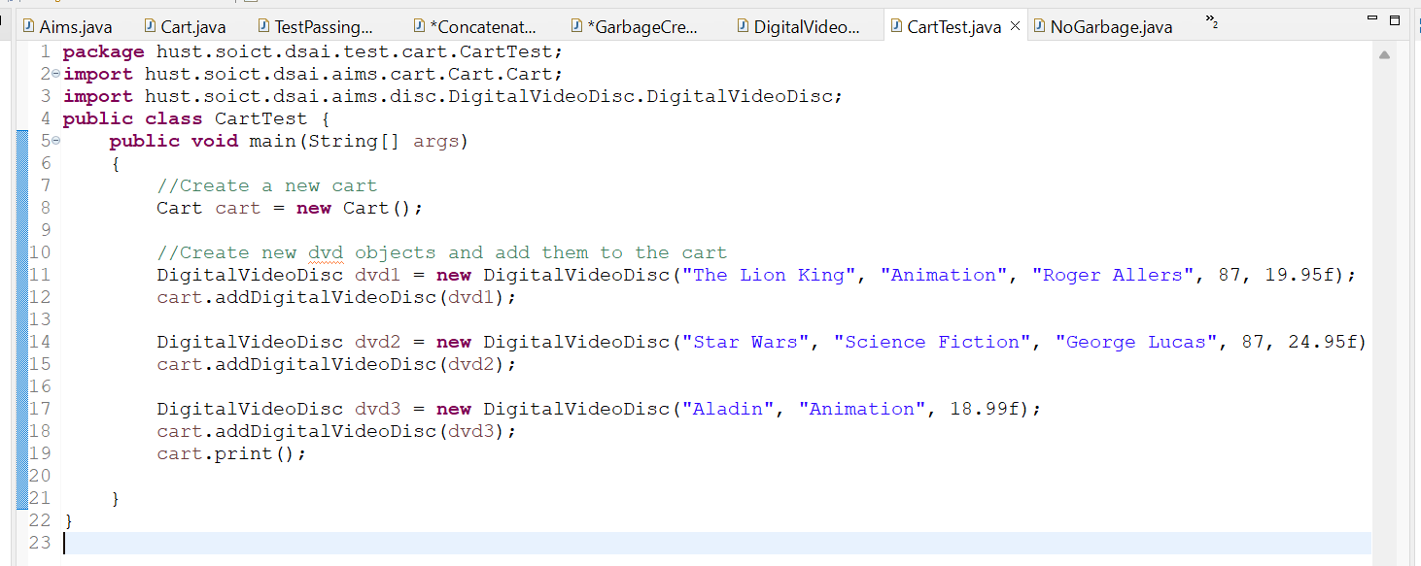

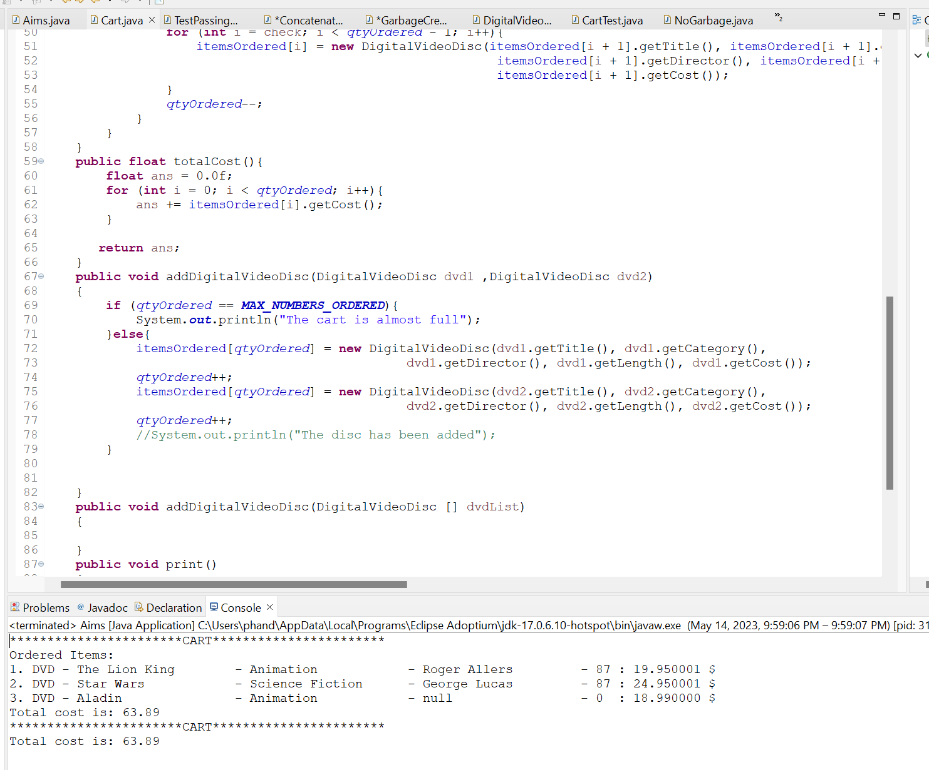

## 7. Implement the Store class

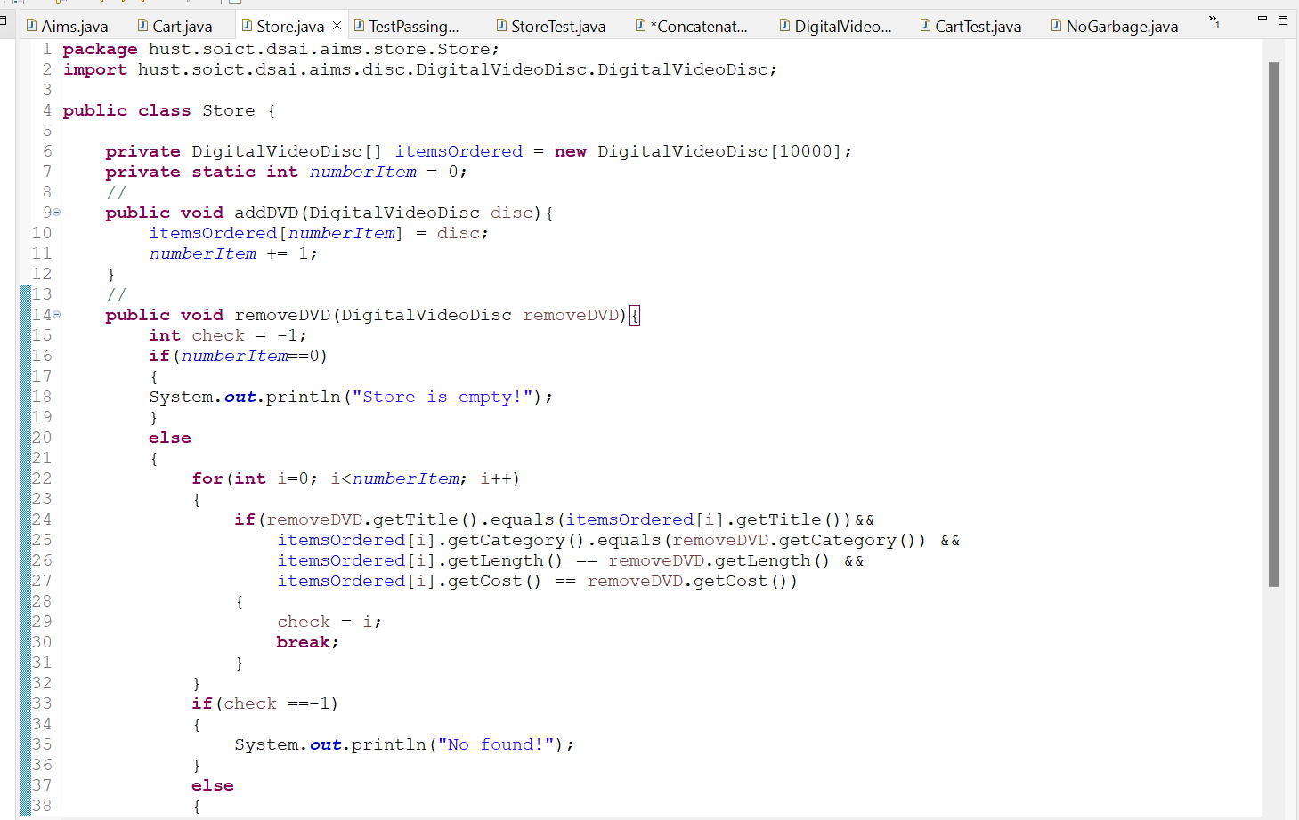

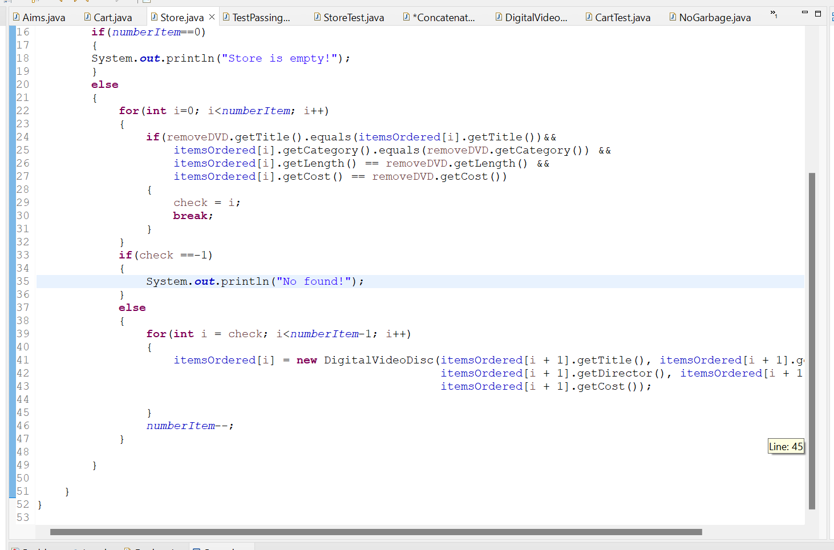



## 8. Re-organize your projects

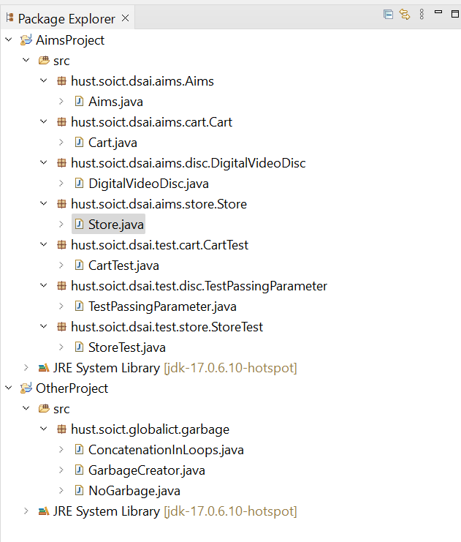

## 9. String, StringBuilder and StringBuffer

